Reception | Autumn 1 | Autumn 2 |  |  | Spring 1 | Spring 2 |  |  |  | Summer 1 |  |  | Summer 2
 | Humanity  Having a voice  Diversity, fairness  Individuality |  |  |  | Innovation  Seizing the chance  Truth, Change,  Resilience |  |  |  |  | The World  Being the change  Responsibility, Equality,  Sustainability
Planned Themes/Directed Learning | Autumn Through the Senses | Let’s Celebrate! |  |  | We’ve got the power! |  | How does it change?  Ready steady grow |  |  | All creatures great and small |  |  | I wonder what’s out there?
Possible areas of Interest linked to this: | All about me  My family  My 5 senses  Where we live-local area.  Autumn Creature  Weather | Do we all celebrate the same thing?  Birthdays. Diwali, Halloween, Bonfire Night, Christmas. |  |  | People who help us  Super heroes,  When I grow up.. |  | Spring, Baby Animals, how we have changed? Plants, flowers, weather, Life cycles |  |  | Pets, Zoo animals, farm animals, jungle animals, Insects, Sea creatures. |  |  | Space, dinosaurs, imaginary lands, Seaside. Transition to Year 1.
Curriculum Enrichment & Key Dates | Stockswood | Stockswood:  Diwali  Halloween 31st Oct, Bonfire Night 5th Nov  Remembrance 11th Nov, Children in Need  Christmas  EYFS Nativity Dec  Christmas jumper Day |  |  | Stockswood  Chinese New Year  Cultural outreach Music  (phonic/reading focus)  Visits from Emergency Services and PWHU (vet) |  | Stockswood  Pancake Day  World Book Day  Science Week  Red Nose Day  Mothers Day  Living Eggs in class  Claires Cool Creatures  Poetry Day  Spring/Easter Celebration |  |  | Stockswood  Stay and Play:  Eid  Children’s Gardening week  Sports Day |  |  | Stockswood  Walby Farm Park:  Cumberland Show  Fathers Day
Literacy  Core Texts | 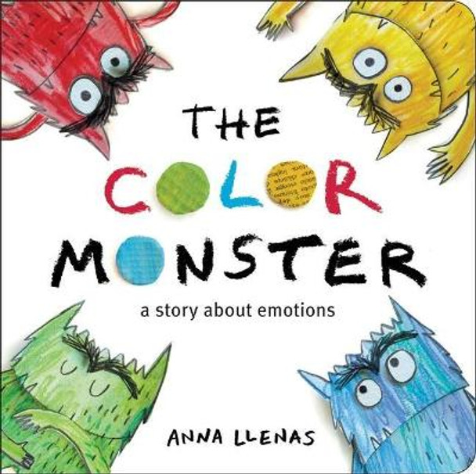  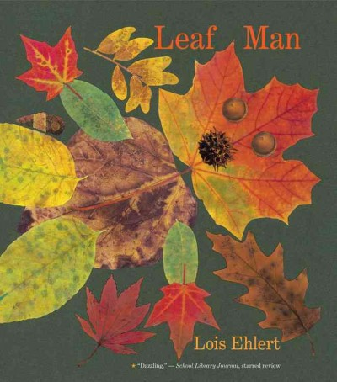  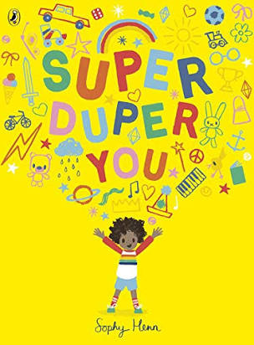  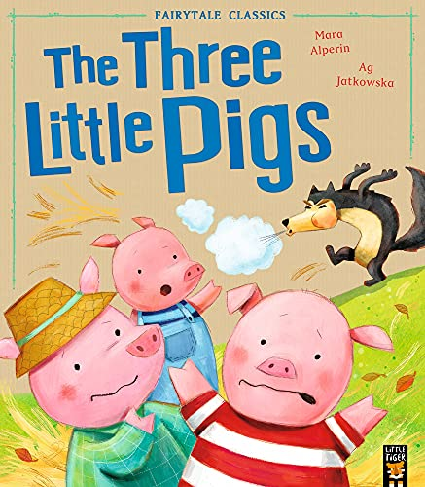 | 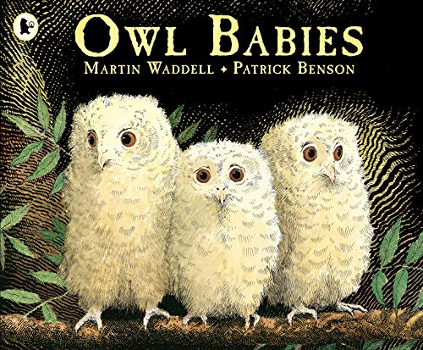  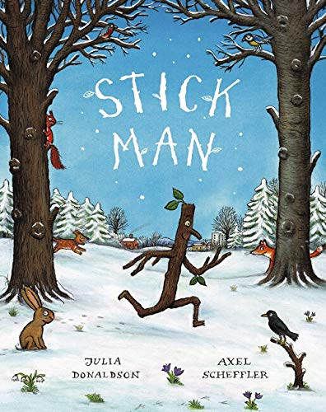  (Plus Non-Fiction texts linked to celebrations) |  |  | 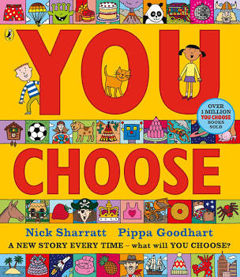  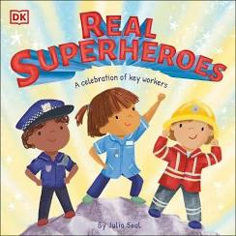  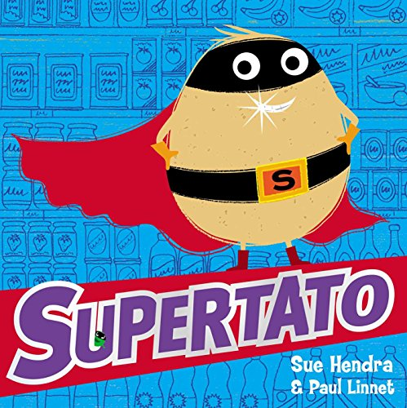  (Plus non-fiction PWHU) |  | 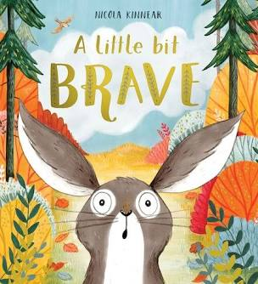  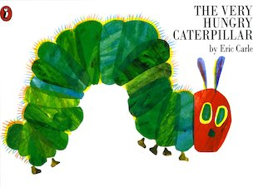  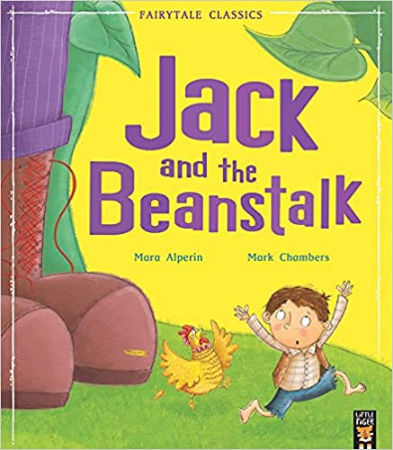  (Plus Poety linked to Spring) |  |  | 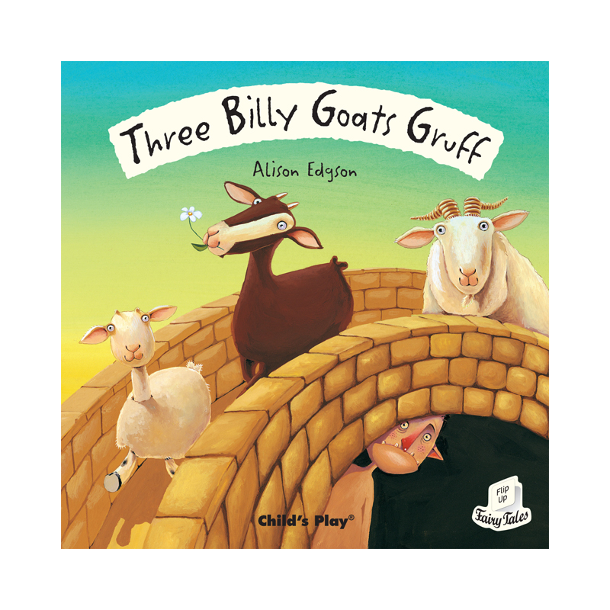  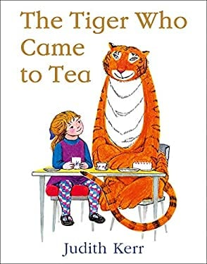  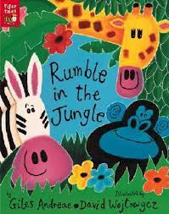 |  |  | 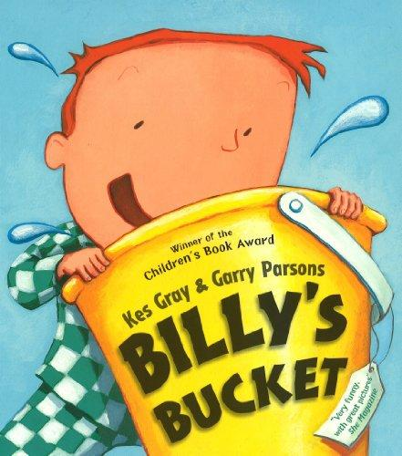  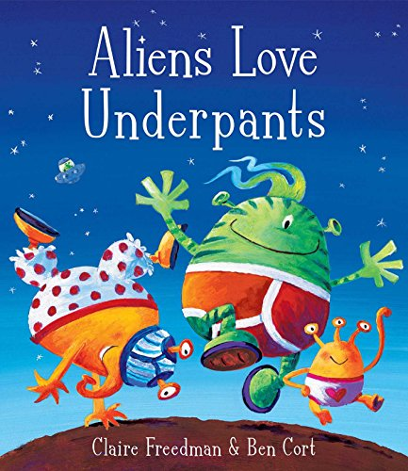  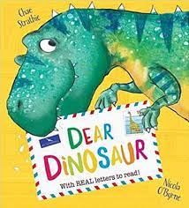
DRAW CLUB  TEXTS | The 3 Little Pigs  The ColourMonster  Not Now Bernard | Owl Babies  Stickman  What’s in Witches Kitchen  Dear Santa |  |  | Burglar Bill  You Choose  Supertata |  | Jack and the Beanstalk  The Very Hungry Caterpillar |  |  | The 3 Billy Goats  Tiger Who Came to Tea |  |  | Aliens Love Underpants  How to Grow a dinosaur
Reception | AUTUMN TERM |  |  |  | SPRING TERM |  |  |  |  | SUMMER TERM
C&L  LISTENING, ATTENTION & UNDERSTANDING | Understand how to listen carefully and why listening is important.  Learn new vocabulary.  Engage in story times.  Listen carefully to rhymes and songs, paying attention to how they sound.  Engage in non-fiction books. |  |  |  | Ask questions to find out more and to check they understand what has been said to them.  Listen to and talk about stories to build familiarity and understanding.  Retell the story, once they have developed a deep familiarity with the text; some as exact repetition and some in their own words.  Learn new rhymes, poems and songs.  Listen to and talk about selected non- fiction to develop deep familiarity with new knowledge and vocabulary. (People Who Help Us non fiction) |  |  |  |  | Listen attentively and respond to what they hear with relevant questions, comments and actions.  When being read to and during whole class discussions and small group interactions. Make comments about what they have heard and ask questions to clarify their understanding.  Hold conversation when engaged in back-and-forth exchanges with their teacher and peers
C&L  SPEAKING | Use new vocabulary through the day. Articulate their ideas and thoughts in well- formed sentences.  Connect one idea or action to another using a range of connectives. |  |  |  | Describe events in some detail.  Use talk to help work out problems and organise thinking and activities, and to explain how things work and why them might happen.  Develop social phrases.  Use new vocabulary in different contexts. |  |  |  |  | Participate in small group, class and one-to-one discussions, offering their own ideas, using recently introduced vocabulary.  Offer explanations for why things might happen, making use of recently introduced vocabulary from stories, non-fiction, rhymes and poems when appropriate.  Express their ideas and feelings about their experiences using full sentences, including use of past, present and future tenses and making use of conjunctions, with modelling and support from their teacher
PSED  SELF REGULATION | Express their feelings and consider the feelings of others.  Develop appropriate ways to be assertive.  Talk with others to solve conflicts. |  |  |  | Identify and moderate their own feelings socially and emotionally.  Think about the perspectives of others. |  |  |  |  | Show an understanding of their own feelings and those of others, and begin to regulate their behaviour accordingly.  Set and work towards simple goals, being able to wait for what they want and control their immediate impulses when appropriate.  Give focused attention to what the teacher says, responding appropriately even when engaged in activity.  Show an ability to follow instructions involving several ideas or actions.
PSED  MANAGING SELF  LINKS TO DT | Remember rules without needing an adult to remind them, understanding why they are important.  Show resilience and perseverance in the face of challenge.  Be increasingly independent in meeting their own care needs  Manage their own needs including putting on own coat and shoes. |  |  |  | Be independent in meeting their own care needs, washing hands after toilet/before lunch etc.  Talk about ways to care for their teeth. Links to Smile for Life oral hygiene.  To understand the principles of a healthy and varied diet. Talk about foods we should eat more/less of to stay healthy.  To discuss ways to keep safe online including having sensible amounts of screen time. |  |  |  |  | Be confident to try new activities and show independence, resilience and perseverance in the face of challenge.  Explain the reasons for rules, know right from wrong and try to behave accordingly.  Manage their own basic hygiene and personal needs, including dressing, going to the toilet and understanding the importance of healthy food choices.  Explore different fruits and vegetables using senses I know where different fruits and vegetables are grown (links to wider world)  To have an understanding of the foods we need to stay fit and healthy  I can design my own pizza for a healthy snack
PSED  BUILDING RELATIONSHIPS | Develop their sense of responsibility and membership of a community.  Become more outgoing with unfamiliar people, in the safe context of their setting.  Show more confidence in new social situations  Build constructive and respectful relationships. |  |  |  | See themselves as a valuable individual. Express their feelings and consider the feelings of others. |  |  |  |  | Work and play cooperatively and take turns with others.  Form positive attachments to adults and friendships with peers.  Show sensitivity to their own and to others’ needs.
Links to  PSHE | Being Me in My World  Self Identity, understanding feelings, Being part of classroom, Being gentle, Rights and Responsibilities. |  | Celebrating Difference  Identifying talents. Being special unique, families, where we live, making friends, stand up for yourself |  | Dreams and Goals  Challenges, perseverance, goal setting, overcoming obstacles, seeking help, jobs, achieving goals |  |  | Healthy Me  Exercising bodies, physical activity, Healthy Food, Sleep, Keeping clean safely. |  | Relationships  Family life, friendships, breaking friendships, falling out, dealing with bullying, Being a good friend. | Changing Me  Bodies, respecting my body, growing up, Growth and Change, Fears and Fun, Celebrations.
PHYSICAL DEVELOPMENT  GROSS  MOTOR | Revise and refine the fundamental movement skills they have already acquired: - Rolling - Crawling - Walking - Jumping - Running - Hopping - Skipping – Climbing  Progress towards a more fluent style of moving, with developing control and grace. Confidently and safely use a range of large and small apparatus indoors and outside, alone and in a group.  Use large-muscle movements to wave flags and streamers, paint and make marks. |  |  |  | Use their core muscle strength to achieve a good posture when sitting at a table or sitting on the floor.  Combine different movements with ease and fluency.  Further develop and refine a range of ball skills including: throwing, catching, kicking, passing, batting and aiming. |  |  |  |  | Develop the overall body strength, co-ordination, balance and agility needed to engage successfully with future physical education sessions and other physical disciplines including dance, gymnastics, and multi skills.  Develop confidence, precision and accuracy when engaging in activities that involve a ball.  Negotiate space and obstacles safely, with consideration for themselves and others.  Demonstrate strength, balance and coordination when playing.  Move energetically, such as running, jumping, dancing, hopping, skipping and climbing.
Links to PE UNITS | Unit 2: Intro to PE  Action Ants: |  |  | Unit 1: Dance  Fundamentals/Large Apparatus | Gymnastics: (Kim)  Games unit 2 |  |  |  | Unit 2 Dance  Ball Skills | Fundamentals/Large app  Yoga |  | Action Ants  Gymnastics unit 2
PHYSICAL DEVELOPMENT  FINE  MOTOR | Use one-handed tools and equipment, for example, making snips in paper with scissors.  Use a comfortable grip with good control when holding pens and pencils. Show a preference for a dominant hand.  Be increasingly independent as they get dressed and undressed, for example, putting coats on and doing up zips.  Develop their small motor skills so that they can use a range of tools competently, safely and confidently. Suggested tools: pencils for drawing and writing, paintbrushes, scissors, knives, forks, spoons. |  |  |  | Develop the foundations of a hand writing style which is fast, accurate and efficient. |  |  |  |  | Hold a pencil effectively in preparation for fluent writing – using the tripod grip in almost all cases.  Use a range of small tools, including scissors, paintbrushes and cutlery.  Begin to show accuracy and care when drawing.
LITERACY  WORD READING | Develop their phonological awareness to:  • Spot rhymes in familiar stories and poems. Count or clap syllables in a word.  Recognise words with the same initial sound.  Begin to read individual letters by saying the sounds for them.  Begin to blend sounds into words, so that they can read short words made up of known letter– sound correspondences.  Begin to read CVC words containing known letter-sound correspondences  RWI- Read all set 1 sounds, blend sounds into words orally.  Read set 1.3-1.7 with increasing fluency (after oral blending confidently) |  |  |  | Develop their phonological awareness to: • Able to complete a rhyming string.  Begin to use sound buttons to identify how many sounds are in a word.  RWI – blend sounds to read words; read short ditty stories (PCM/books). Intro to set 2 sounds.  Read set 1.3-1.7 with increasing fluency. Read some red words by sight. the, I, no, of, my, for, he.  Can supply words with the same initial sound. Recognise all taught Set 1 including some digraphs. (Special friends)  Re-read phonetically decodable books to build up their confidence in word reading, their fluency and their understanding and enjoyment.  Blend sounds into words, so that they can read short words made up of known letter– sound correspondences.  Read simple sentences containing known letter sound correspondences containing 1 or 2 common words |  |  |  |  | Develop their phonological awareness to: •  Recognise and use rhyme in daily conversation. •  Use sound buttons to segment and read words. •  Can identify words containing the same digraph or trigraph e.g. ay- may, day, play.  Say a sound for each letter in the alphabet and at least 10 diagraphs inc sh,ch,th,ck,ll,ff,ss,zz,ng, nk  Read green purple storybooks, read set 2 sounds and red words.  Read words consistent with their phonic knowledge by sound-blending.  Read aloud simple sentences and books that are consistent with their phonic knowledge, including some common exception words.
LITERACY  COMPREHENSION | Asks questions about stories.  Repeat words and phrases from familiar stories.  Repeat new vocabulary in a context of a story.  Has favourite books and seeks them out, to share with an adult, with another child, or to look at alone. |  |  |  | Answer questions about a text that has been read to them.  Begin to predict what might happen next in a story.  Begin to use modelled vocabulary during role play for example in the Small World. Seeks familiar texts or stories to re-read in the book area. Requests favourite stories and poems. |  |  |  |  | Can share a favourite book with a peer, retelling the story in their own way repeating known phrases from the text.  Demonstrate understanding of what has been read to them by retelling stories and narratives using their own words and recently introduced vocabulary.  Anticipate – where appropriate – key events in stories. Use and understand recently introduced vocabulary during discussions about stories, non-fiction, rhymes and poems and during role-play.
LITERACY  WRITING | Form lowercase letters and capital letters correctly  Use some of their print and letter knowledge in their early writing. Write some or all of their name. Write some letters accurately.  Spell words by identifying the sounds and then writing the sound with letter/s.  Copy full name either independently or from a name label.  Physical Development  Use a range of small tools competently and confidently. |  |  |  | Make good attempts at writing short sentences with words with known sound- letter correspondences,  To begin to show awareness of a capital letter and a full stop in independent writing.  Is able to write their first name independently.  Form many lowercase letters correctly  Begin to use capital letters, finger spaces and full stops in independent writing.  Physical Development:  Develop the foundations of a handwriting style which is fast, accurate and efficient. Begin to use tripod grip. |  |  |  |  | Use a capital letter at the beginning of a sentence and a full stop at the end..  Use finger spaces most of the time.  Write recognisable letters, most of which are correctly formed.  Spell words by identifying sounds in them and representing the sounds with a letter or letters.  Write simple phrases and sentences that can be read by others.  Physical Development  Hold a pencil effectively in preparation for fluent writing. Using the tripod grip in almost all cases
MATHS  WHITE  ROSE  EDUCATION  (See Small Steps Document) | Getting to know you  Match sort and compare  Talk about measure and patterns  Its me 1,2,3!  Circles and triangles  1,2,3,4,5  shapes with 4 sides |  |  |  | Alive in 5  Mass and Capacity  Growing 6,7,8  Length, height and time  Building 9 & 10  Explore 3D Shapes |  |  |  |  | To 20 and beyond  How many now?  Manipulate, compose and decompose  Sharing and groups  Visualise build and map  Make connections  Consolidation
UW  PAST & PRESENT  Links to NC HISTORY | Begin to make sense of their own life story and family setup. (siblings, extended family etc) Explore family photographs, guess who baby photographs.  Discuss families in the past and how they differ from today-homes, clothes etc.  Comment on images of familiar situations in the past.(When they were a baby they could..)  Compare and contrast characters from stories, including figures from the past.  Comment on images of familiar situations in the past. |  |  |  | Talk about the lives of people around them and their lives in society. (occupations etc linked to people who help us. Look at how some of these professions have changed (fire engines past and present)  Read a range of non fiction books about people in the community. What would you like to do when older?  Compare and contract characters from stories, including figures from the past. |  |  |  |  | Talk about the lives of the people around them and their roles in society.  Know some similarities and differences between things in the past and now, drawing on their experiences and what has been read in class. Look at photographs of Cumwhinton in the past.  Look at old toys and compare and contrast to new toys.  Understand the past through settings, characters and events encountered in books read in class and storytelling.
UW  PEOPLE. CULTURE &  COMMUNITIES  LINKS TO NC COMPUTING & GEOGRAPHY | Explore how things work. (using ICT in role play pretend phones/computers)  Continue developing positive attitudes about the differences between people.  Talk about members of their immediate family and community.  Name and describe people who are familiar to them. |  |  |  | Understand that some places are special to members of their community. Recognise that people have different beliefs and celebrate different times in different ways.  Recognise some similarities and differences between religions and civilisations.  Know that there are different countries in the world and talk about the differences they have experienced or seen in photos.  Draw information from a simple map. Explore a variety of maps and use these to create a map of their way to school. Look at OS map of Cumwhinton. Can children identify key features?  Show interest in different occupations (People Who Help Us). Visits from parents as professional..ask questions to find out more. |  |  |  |  | Describe their immediate environment using knowledge from observation, discussion, stories, non-fiction texts and maps.  Know some similarities and differences between different religious and cultural communities in this country, drawing on their experiences and what has been read in class.  Explain some similarities and differences between life in this country and life in other countries, drawing on knowledge from stories, nonfiction texts and (when appropriate) maps.
UW  THE NATURAL WORLD  LINKS TO NC SCIENCE &  GEOGRAPHY | Use all their senses in hands-on exploration of natural materials.  Explore collections of materials with similar and/or different properties. (Three Little Pigs)  Talk about what they see, using a  wide vocabulary.  Talk about the differences between materials and changes they notice. Explore Ice in the outdoor area.  Explore the natural world around them. Note the changes to trees in the garden and the weather. What can we see around our school? Explore immediate environment |  |  |  | Plant seeds and care for growing plants. Understand the key features of the life cycle of a plant and an animal.  Observe and care for living eggs and talk about the changes that occur in the life cycle of a chick.  Begin to understand the need to respect and care for the natural environment and all living things.  To show an awareness of the wider world-share photographs from places they have visited and locate on map. |  |  |  |  | Explore the natural world around them, making observations and drawing pictures of animals and plants.  Know some similarities and differences between the natural world around them and contrasting environments, drawing on their experiences and what has been read in class.  Understand some important processes and changes in the natural world around them, including the seasons and changing states of matter. Talk about changing weather patterns.  Record the weather across a short period of time. Ask children to reflect on each season. Which season is their favourite and why?
EAD  CREATING WITH MATERIALS  LINKS TO NC ART & DT | Explore different materials freely, to develop their ideas about how to use them and what  to make. (To design and make a junk model house for the 3 little pigs)  Join different materials and explore  different textures.(Linked to sense)  Make imaginative and complex ‘small worlds’ with blocks and construction kits, such as a city with different buildings and a park.  Create closed shapes with continuous lines and begin to use these shapes to represent objects line, ziz zags etc.  Draw with increasing complexity and detail, such as representing a face with a circle and including details  Show different emotions in their drawings and paintings, like happiness, sadness, fear, etc.  To look at the work of Kandinsky and create own representations using pastels. |  |  |  | Explore use and refine a variety of artistic effects to express their ideas and feelings.  Return to and build on their previous learning, refining ideas and developing their ability to represent them.  Create collaboratively, sharing ideas, resources and skills.  Develop storylines in their pretend play.  Explore a range of flaps, levers and sliders on familiar toys and books How do we use levels, sliders and flaps with control and care? Design a page for a class book with flaps  To look at work Jackson Pollock and create own representations using paint. Explore colour and colour mixing including using vocabulary linked to shade. (light/dark blue) |  |  |  |  | Safely use and explore a variety of materials including clay , tools and techniques, experimenting with colour, design, texture, form and function.  (explore skill of imprinting with clay-fossils)  Share their creations, explaining the process they have used.  Make use of props and materials when role playing characters in narratives and stories.  To look at sculptures in the environment (Stocks Wood) and create own sculptures in the style of Andy Goldsworthy.
EAD  BEING IMAGINATVE & EXPRESSIVE | Sing in a group and individually a range of new and known songs.  Learn how to handle, name and play un tuned instruments and play them with increasing control.  Listen attentively, move to and talk about music, expressing their feelings and responses. (Dance unit 1)  Take part in a Christmas production for an audience inc singing and learning new songs. |  |  |  | Sing in a group or on their own, looking at repetitive phrases call and respond to learn new songs . (specialist singing teacher)  Play instruments with increasing control  to express their feelings and ideas. Using a range of dynamics and signals eg Loud, quiet, fast slow, start, stop.  Listen and respond to a range of music and express how they feel and make comparisons.  Perform to an audience as part of a whole school singing celebration. |  |  |  |  | Invent, adapt and recount narratives and stories through music with peers and their teacher. (Dance Unit 2)  Use instruments to follow a steady beat and to create mood within stories.  Sing a range of well-known nursery rhymes and songs.  Perform songs, rhymes, poems and stories with others, and when appropriate try to move in time with the music.
RE | To explore festivals that are celebrated around the world including Diwali, Harvest, Christmas (Advent)  An introduction to the nativity story and perform for parents. |  |  |  | To explore special objects and link this to special objects in other religions such as Christianty.  To find out about the Easter story and what Easter means for Christians. Link to new life all around . (Living eggs, spring animals. |  |  |  |  | What can we learn from stories? What stories are special to Christians. Noah Ark.  Where is your special place? Explore special buildings and places of worship in other cultures

