

Reception
Prospectus 2024/25

Inspired by Cumbria, ready for the world…
As the Early Years Lead at Cumwhinton School, it is with very warm wishes that I welcome you to our school.
We have bold ambitions for all of our children; Cumwhinton is a place where children and our community are at the heart of all that happens, a place where every individual’s ability is recognised, developed and rewarded.
At Cumwhinton we pride ourselves on our inclusive and child-centred values which recognise the essential skills children will need if they are to become successful and thriving young people and adults. This includes those attributes that will enable them to relish learning and seek to want to know more about the world and their role in its future. Everything about our school is carefully considered to ensure that our children are confident in themselves but also in their role as citizens, both locally and globally.
At Cumwhinton we have three school values. Over the course of the academic year, children will have the opportunity to explore more deeply each of our school values in a planned and progressive way.
HUMANITY  ~having a voice~ | INNOVATION  ~seizing the chance~ | THE WORLD  ~being the change~
We are situated in the beautiful village of Cumwhinton, South East of Carlisle. This truly glorious location provides us with a fabulous backdrop from which to be “…inspired by Cumbria…” and all that the rich and varied heritage, landscape and social dynamics of the region has to offer our children. It is vital to us that the children have a strong sense of their local surroundings and a pride in where they are learning.
Our curriculum is carefully designed taking into account the needs of the children at our school; it is bespoke, progressive and builds towards immersing them knowledge, skills and aptitude they need to take advantage of opportunities and experiences in later life. Central to this is ensuring that our youngest children are given the very best start to their learning journey; we prioritise giving children both the skills and the self-belief they need to be successful.
We pride ourselves on our open and friendly approach and our ‘family’ feel. There is never a question too small, so please if you have any queries, please don’t hesitate to get in contact with us at school.

Cumwhinton School
We redesigned our school logo with the help of our children. It helps us to be reminded of the values in our school, but also our approach to learning and the ambition we have for your child.

The parnassuss flower; the flower of wet and wilderness as depicted on the flag of Cumberland. This represents our commitment to the rich and varied heritage, landscape and social dynamics of Cumbria. It is vital to us that the children have a strong sense of their local surroundings and a pride in where they are learning.

The hands; represent the ambition of HUMANITY within our school and curriculum with the conceptual drivers that confirm our commitment to widening our children’s experience and field of reference.

The red circle; in the centre of the flower is a red circle which represents our ambition of INNOVATION; from a tiny seed, great ideas begin. Our conceptual drivers support our commitment to developing the whole child in respect of their learning behaviours and the aptitudes they need to develop to become life-long learners.

The blue swirls; represent the focus of THE WORLD and the importance of having a global outlook. Our conceptual drivers confirm our commitment to ensuring that children understand their role as global citizens and having the confidence to make a change.


The Early Years at Cumwhinton
Here at Cumwhinton School, we strongly believe the best way to inspire your child is by providing opportunities for them to be amazed; enabling their curiosity to drive their learning, valuing the impact of time to explore the great outdoors and question new things along the way. Our approach to curiosity can be seen throughout our provision and in the way our staff support your child to become independent in their own learning. As part of our daily sessions, your child will have the opportunity not only to explore our indoor environments but school grounds too. We want to enable your child to go on their own adventures and follow their own imagination. Your child will become an explorer, learn to have a voice, seize the chance and be the change. We are delighted that in our most recent Ofsted (November 2023) the Early Years at Cumwhinton was awarded an OUTSTANDING grading.

Our provision is set up with your child at the centre of everything we offer. Our skilled staff understand the learning and development of your child and use the provision to enhance the experiences your child has, ensuring that they are filled with wonder and curiosity. Alongside daily phonics, literacy and maths small group sessions, and whole class input your child will take part in a plan, do, review process. In this process the children plan what they would like to do, have a long period of uninterrupted play and then reflect on their achievements. In doing so, the children learn to take initiative, solve problems, work with others and accomplish their goals.
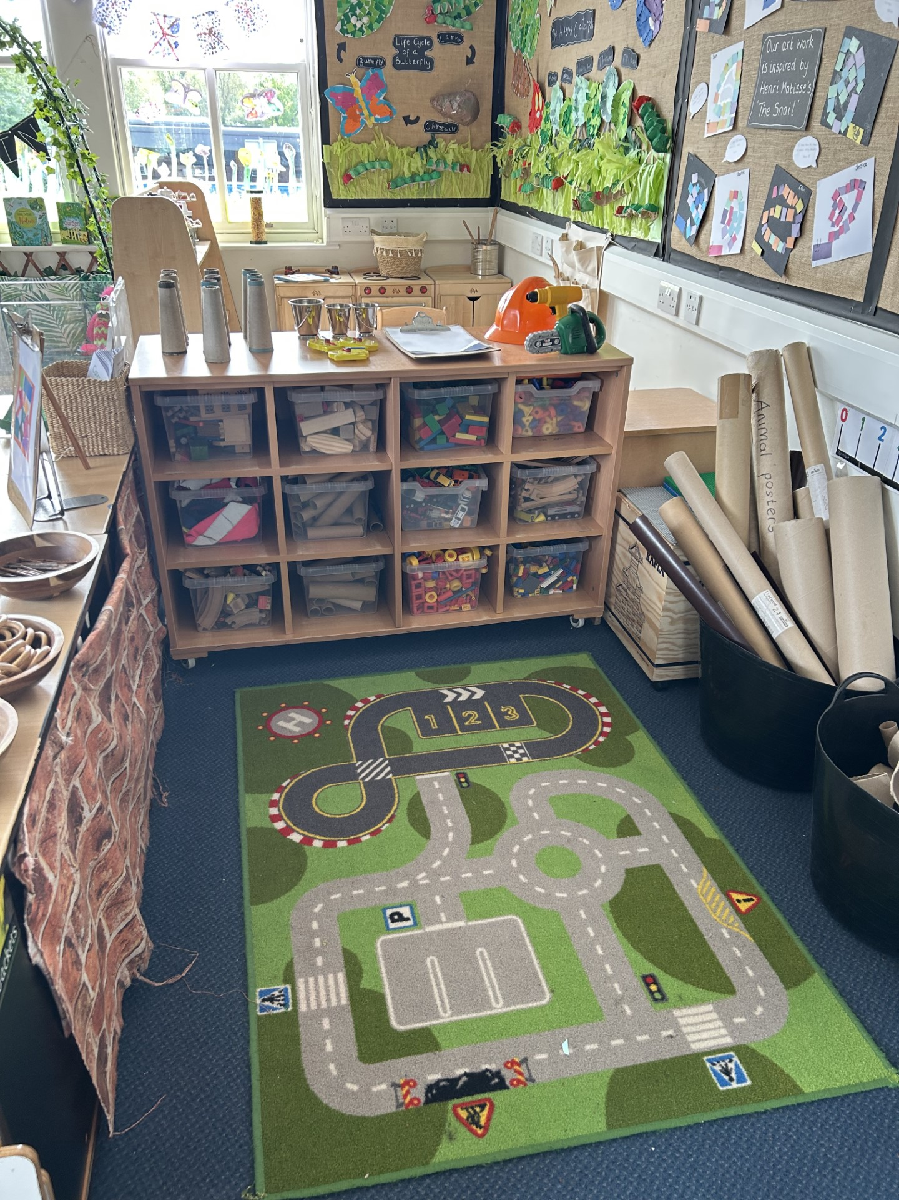
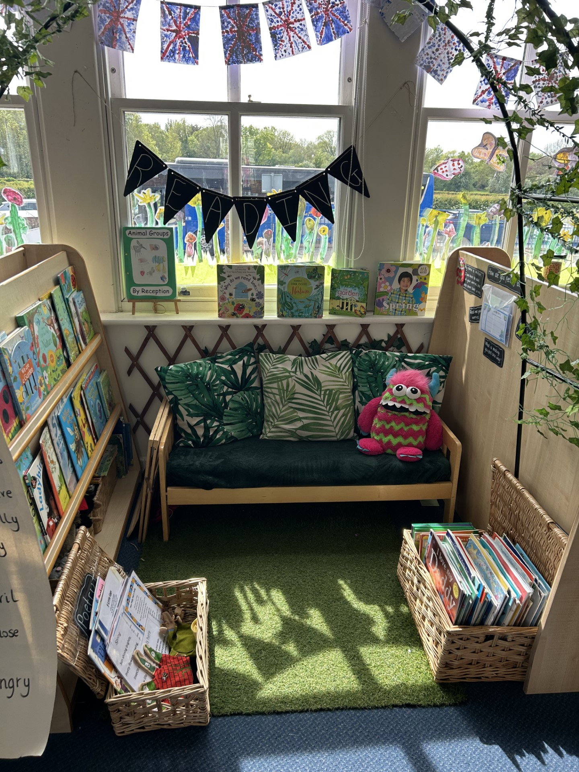
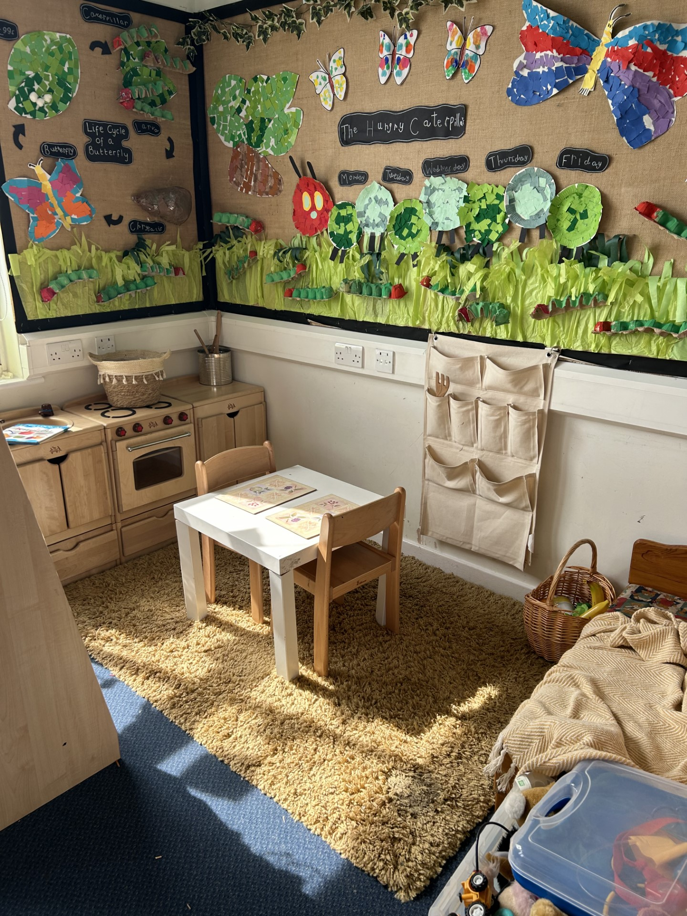

THE GREAT OUTDOORS
It is important that your child has the opportunity to explore outdoors whatever the weather. We learn best from real experiences, seeing how the weather changes throughout the year, what impact this has on the environment and how we adapt for the weather is absolutely what we want your child to know. Please ensure that your child has appropriate outdoor clothing for all weathers! We kindly ask for a pair of named wellies to stay in school for Stocks Wood and for when we do activates on the field. On colder days, the time we spend outside may be shorter to compensate for this, but whatever the weather, there is fun to be had.
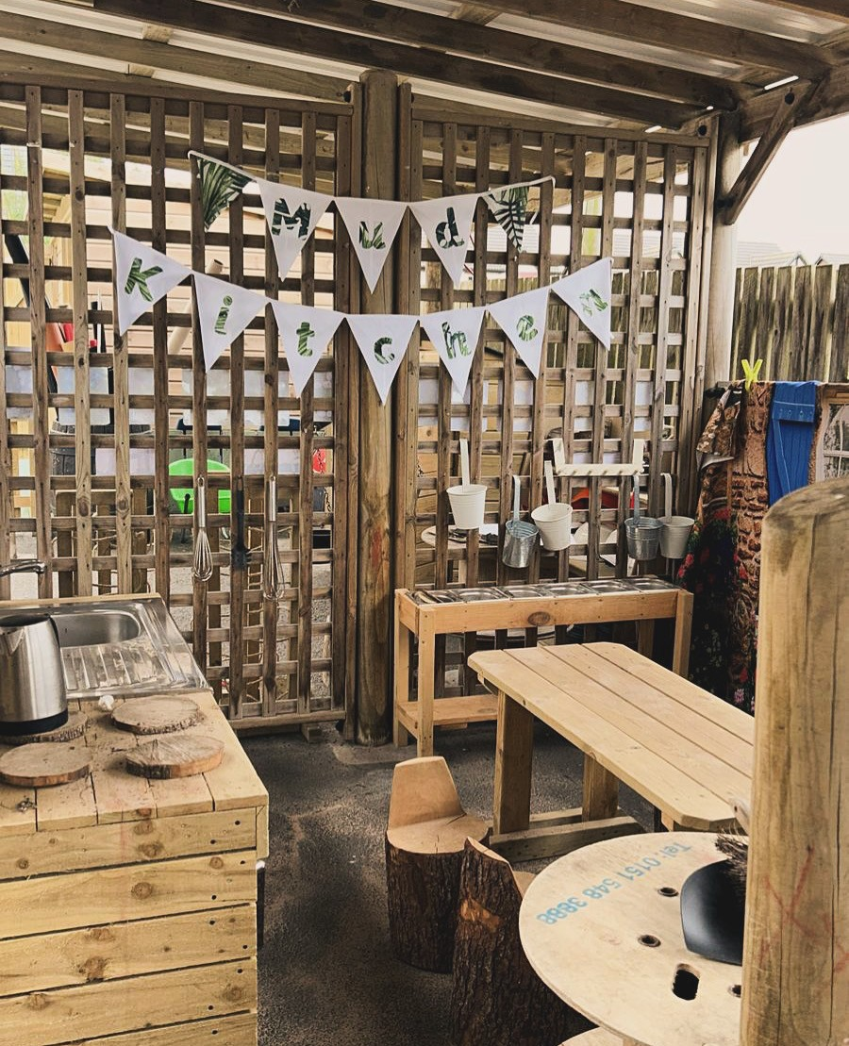
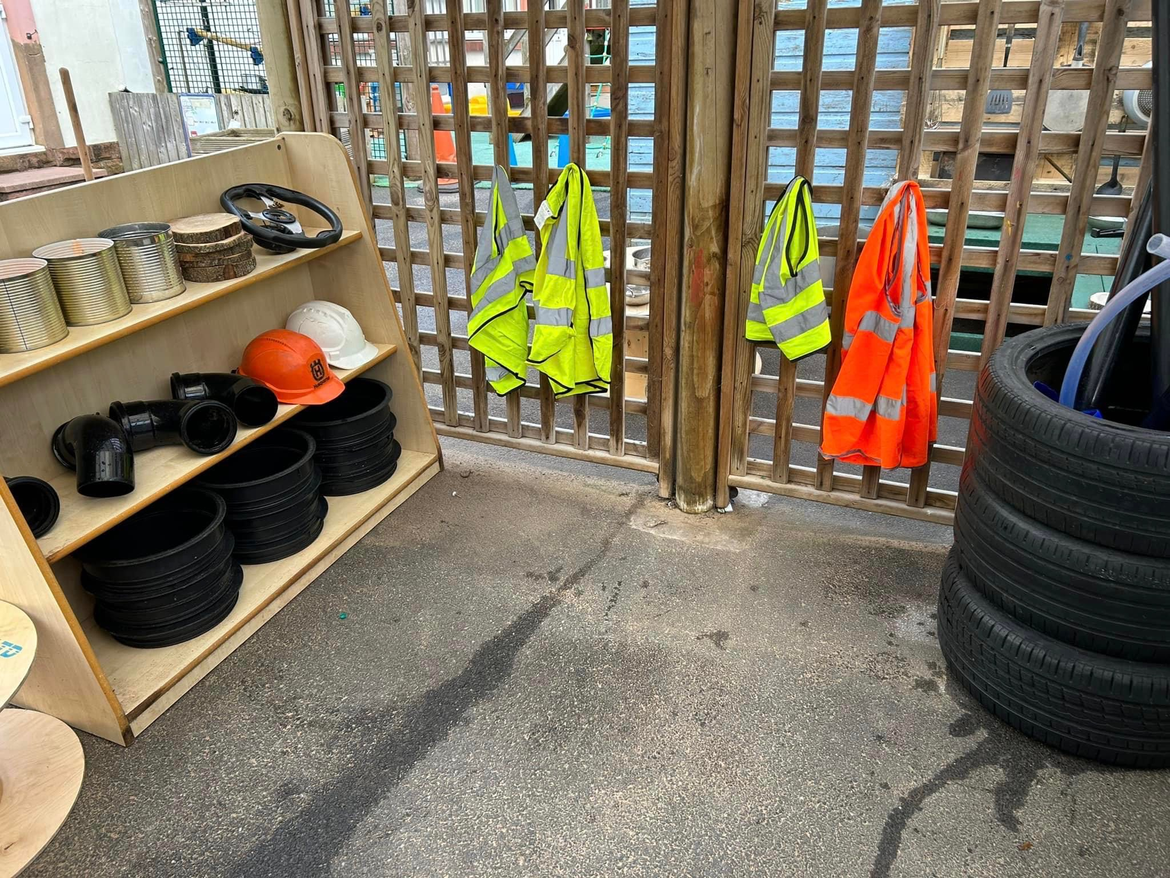

ENRICHMENT
Linking with our values, all of our children visit Stocks Wood outdoor centre for a morning session every half-term. Every visit is carefully planned by the Mrs Anderson and staff at Stocks Wood. Part of the cost of this is funded through our sports premium funding allocation, however in order to facilitate this we do require a payment per session (more info to follow). The sessions are progressive throughout the year and give children the opportunity to explore and learn beyond the classroom. The children also have the opportunity to go on an alternative school trip in the Summer Term.
We also plan opportunities for children to experience high quality hands on learning by arranging visit to school from professionals such as emergency services as part of our topic work. During Spring term the children have the opportunity to watch chicks hatch in the classroom. We also have a visit from Claire’s Cool Creatures during our Animals topic.

Each term we invite parents and carers into school for stay and play sessions. This gives parents an insight into how children access the provision and is an opportunity for us to show-case their learning with you. This is a fun occasion to become immersed in our learning and take part in a range of opportunities alongside your child.

It is important to us that your child has a sense of belonging within their local area. We have been working hard to develop strong links within our local community to give your children a sense of pride. Our values and curriculum inspire the children to learn about local geography and history in a carefully planned, sequential curriculum.

A SNAPSHOT FROM STOCKS WOOD…

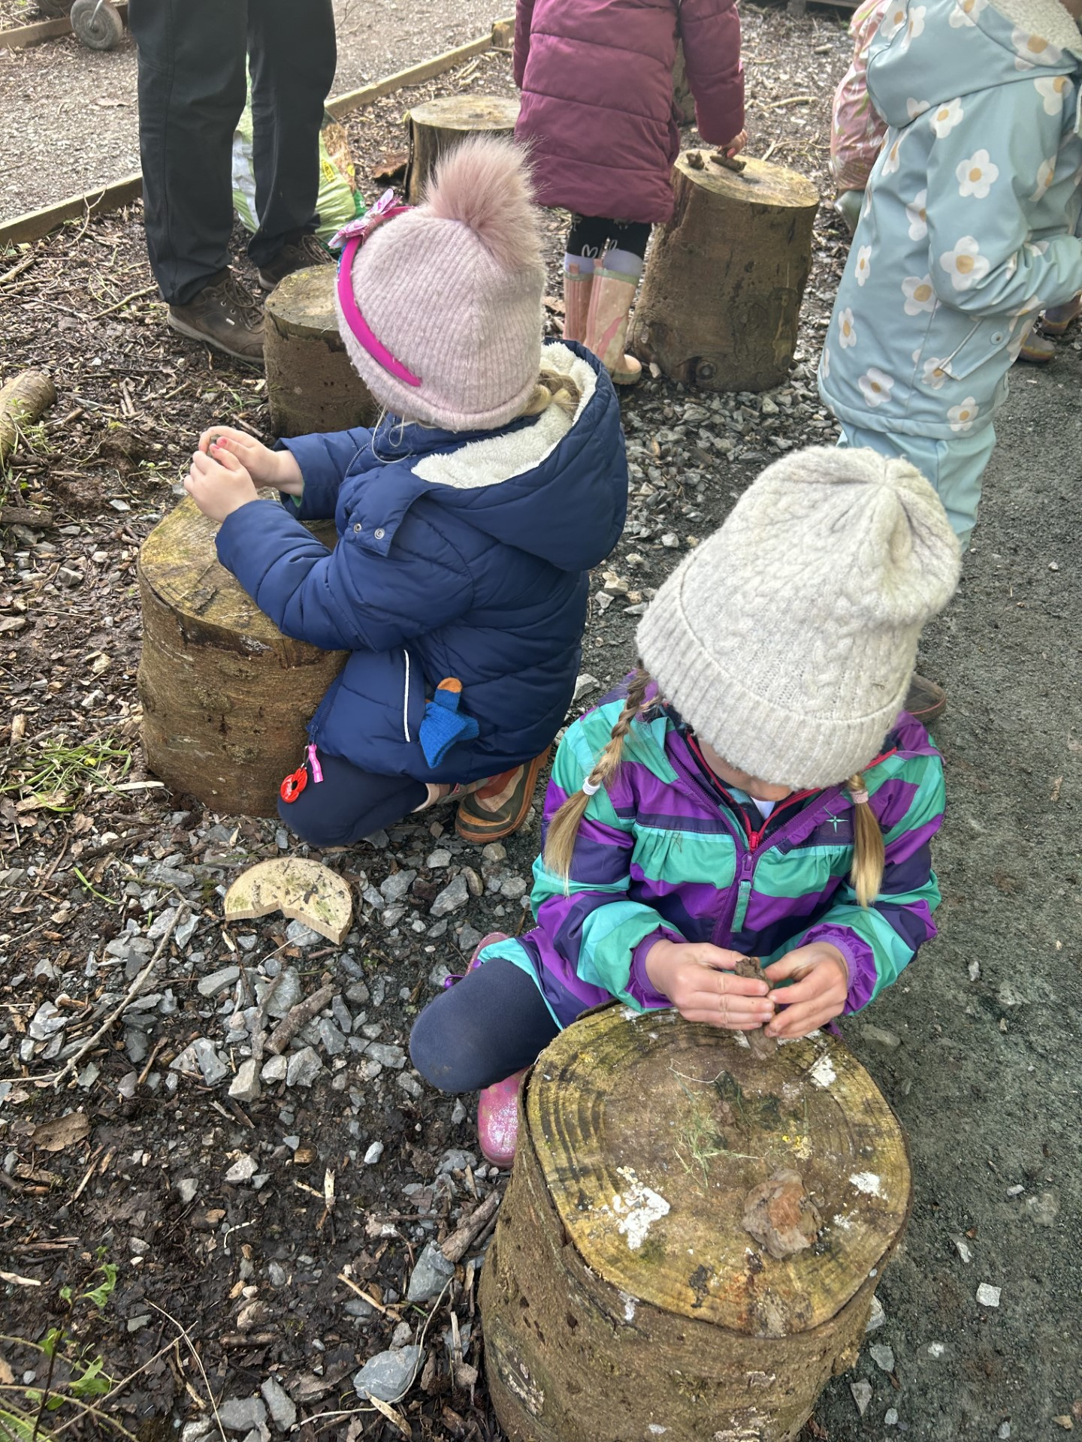
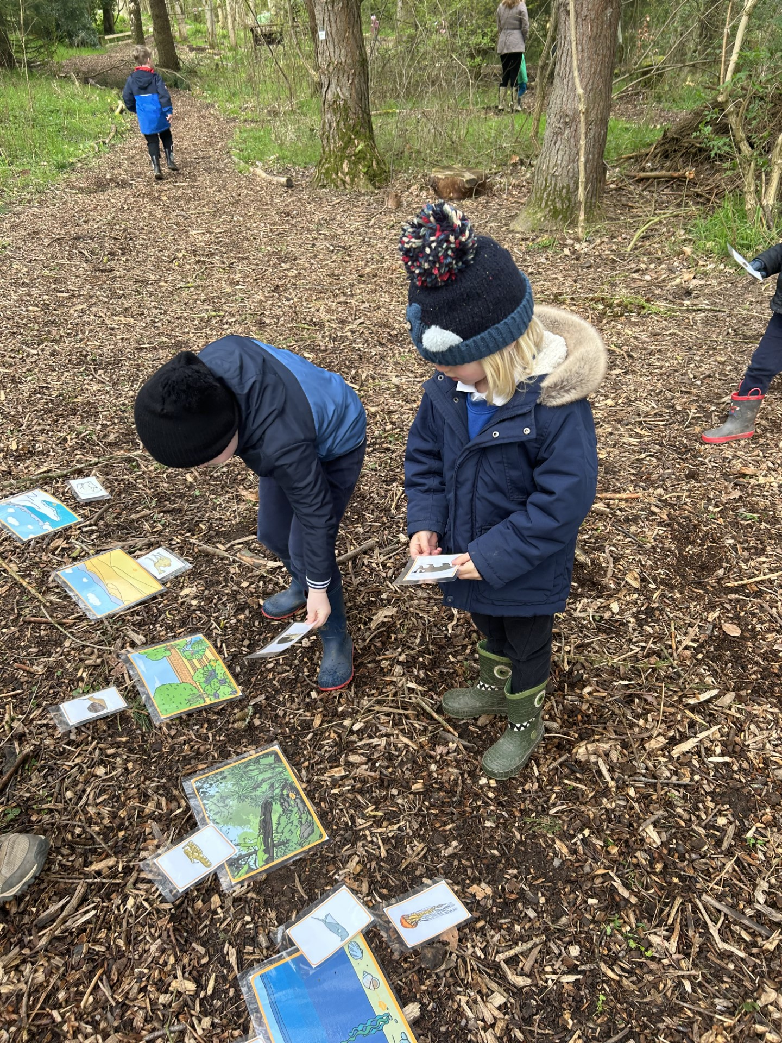
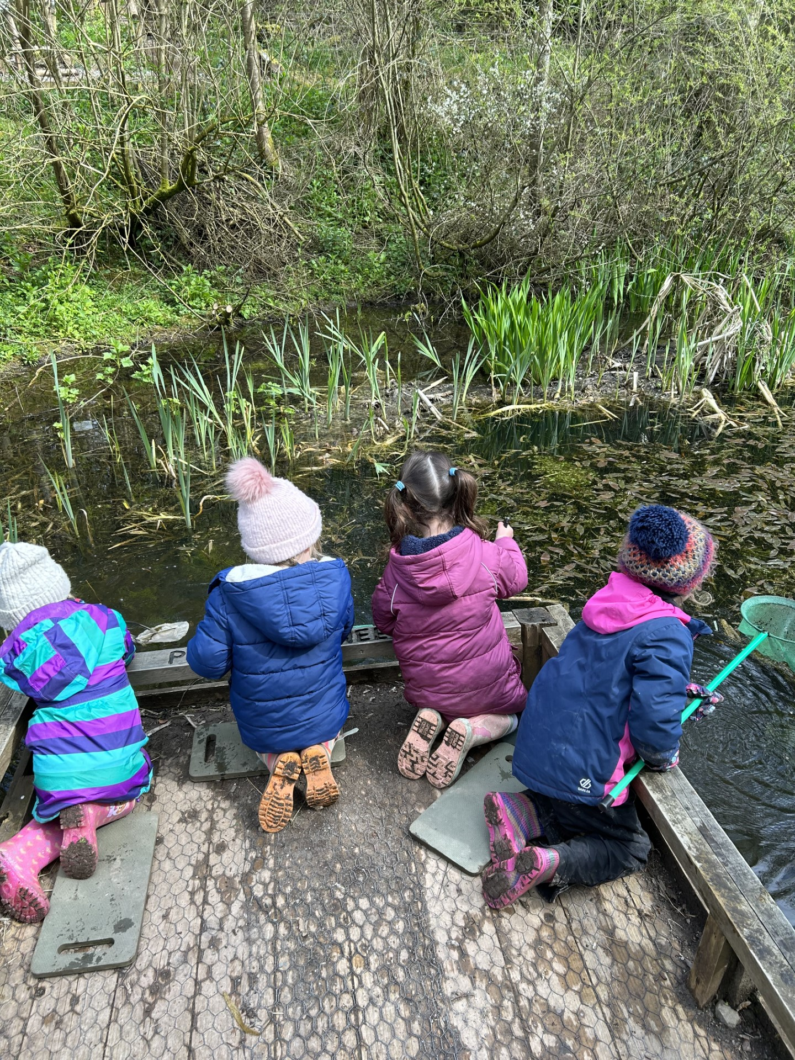

EARLY READING AT CUMWHINTON
We have really invested in ensuring that our children have the very best opportunities to develop a real love of reading. We recognise the importance of exposing our children to the best texts and have developed a reading spine throughout the school of classics which we don’t want our children to miss out on.
We also encourage our children to read throughout our provision inside and outside, during their child initiated time. All staff at Cumwhinton recognise the importance of reading and we use every opportunity to read and enjoy stories, poems and non- fiction texts with the children. We want all of our children to learn to read so that they can read to learn.
At Cumwhinton we recognise the importance of developing early reading skills. We teach the children using Read Write Inc in a daily phonics session. Our youngest children have daily immersion in phase 1 to develop core pre-reading skills. This allows the children when they begin learning sounds to work through each sound systematically and at pace. Phonics teaches the children to read accurately, fluently and develop good comprehension skills.

COMMUNICATION WITH FAMILIES

At Cumwhinton, we strongly value the enduring support of our parents and carers. We recognise that parents are the child’s primary educator and we recognise this important role through regular engagement including:

• Initial information and admission support for completion of admission forms and to sign permission slips for visits out of school, use of photographs of their child for assessment purposes and using the internet at school if required.
• Having an open door policy to enable parents to come and speak with staff should they have any concerns.
• Parents evenings, invitation to book looks and regular updates.
• Regular parents’ events; stay and plays, music sessions, early reading support etc.
• Events and activities throughout the year which bring together children, parents and the school.
• Sending activities home for parents to complete with their children.

•Daily communication with parents using a secure online platform called SEESAW. This is an app which allows parents/ carers to see photos and videos of their children. It allows our teachers to share your child’s learning and development on a personal level and share real WOW moments during the day.
It is also a platform for parents to share home-learning and significant events in your child’s life.

How to access Seesaw..
You child’s teacher set up a class account with your child’s name. You will then have receive a seesaw invitation through email which will have had a code or a QR code for you to access. The invitation will have directed you to access Seesaw through laptop/ desktop, or by downloading the Seesaw family app.
Laptop/ desktop access – You will go on to the Seesaw website and there will be three choices. You are directed to click on the third choice which is family member. Here your computer will ask to access the camera so that you can scan the QR code. After that, your child’s class teacher will approve your access and you will be able to view your child’s journal and the messages sent to your inbox by the class teacher.
Phone/ tablet – Parents will need to download the seesaw app ‘Seesaw family’, you will be asked to scan the QR code and enter an email address and password when creating your account.



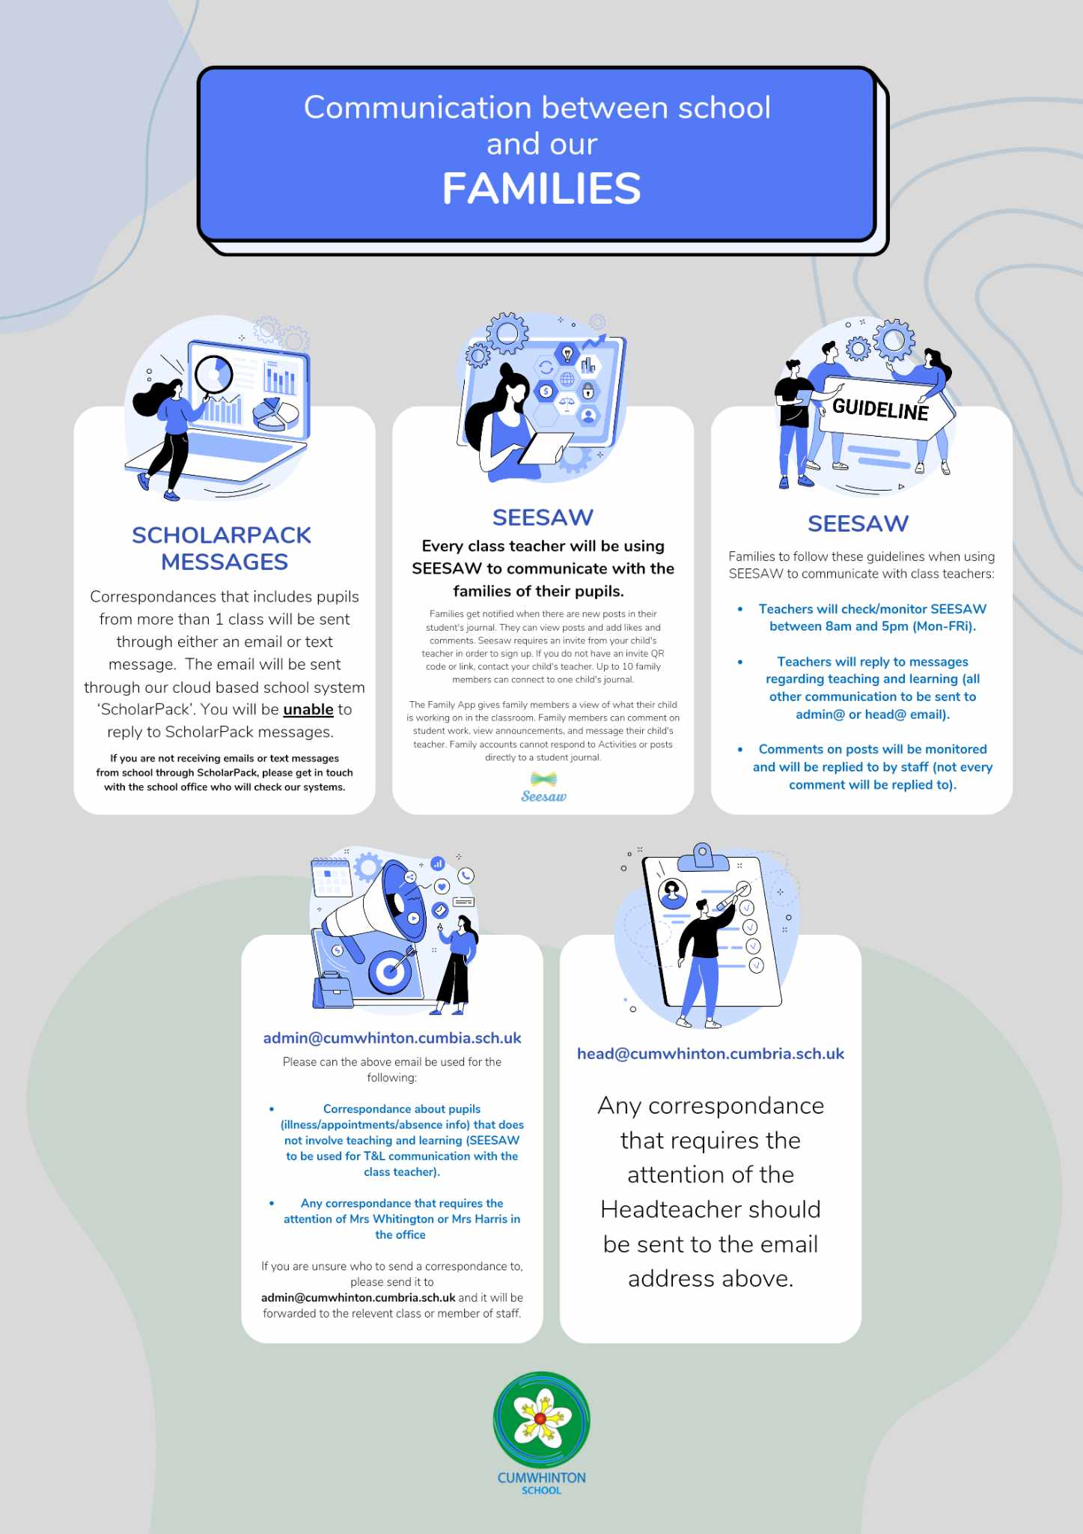

MEET THE STAFF…

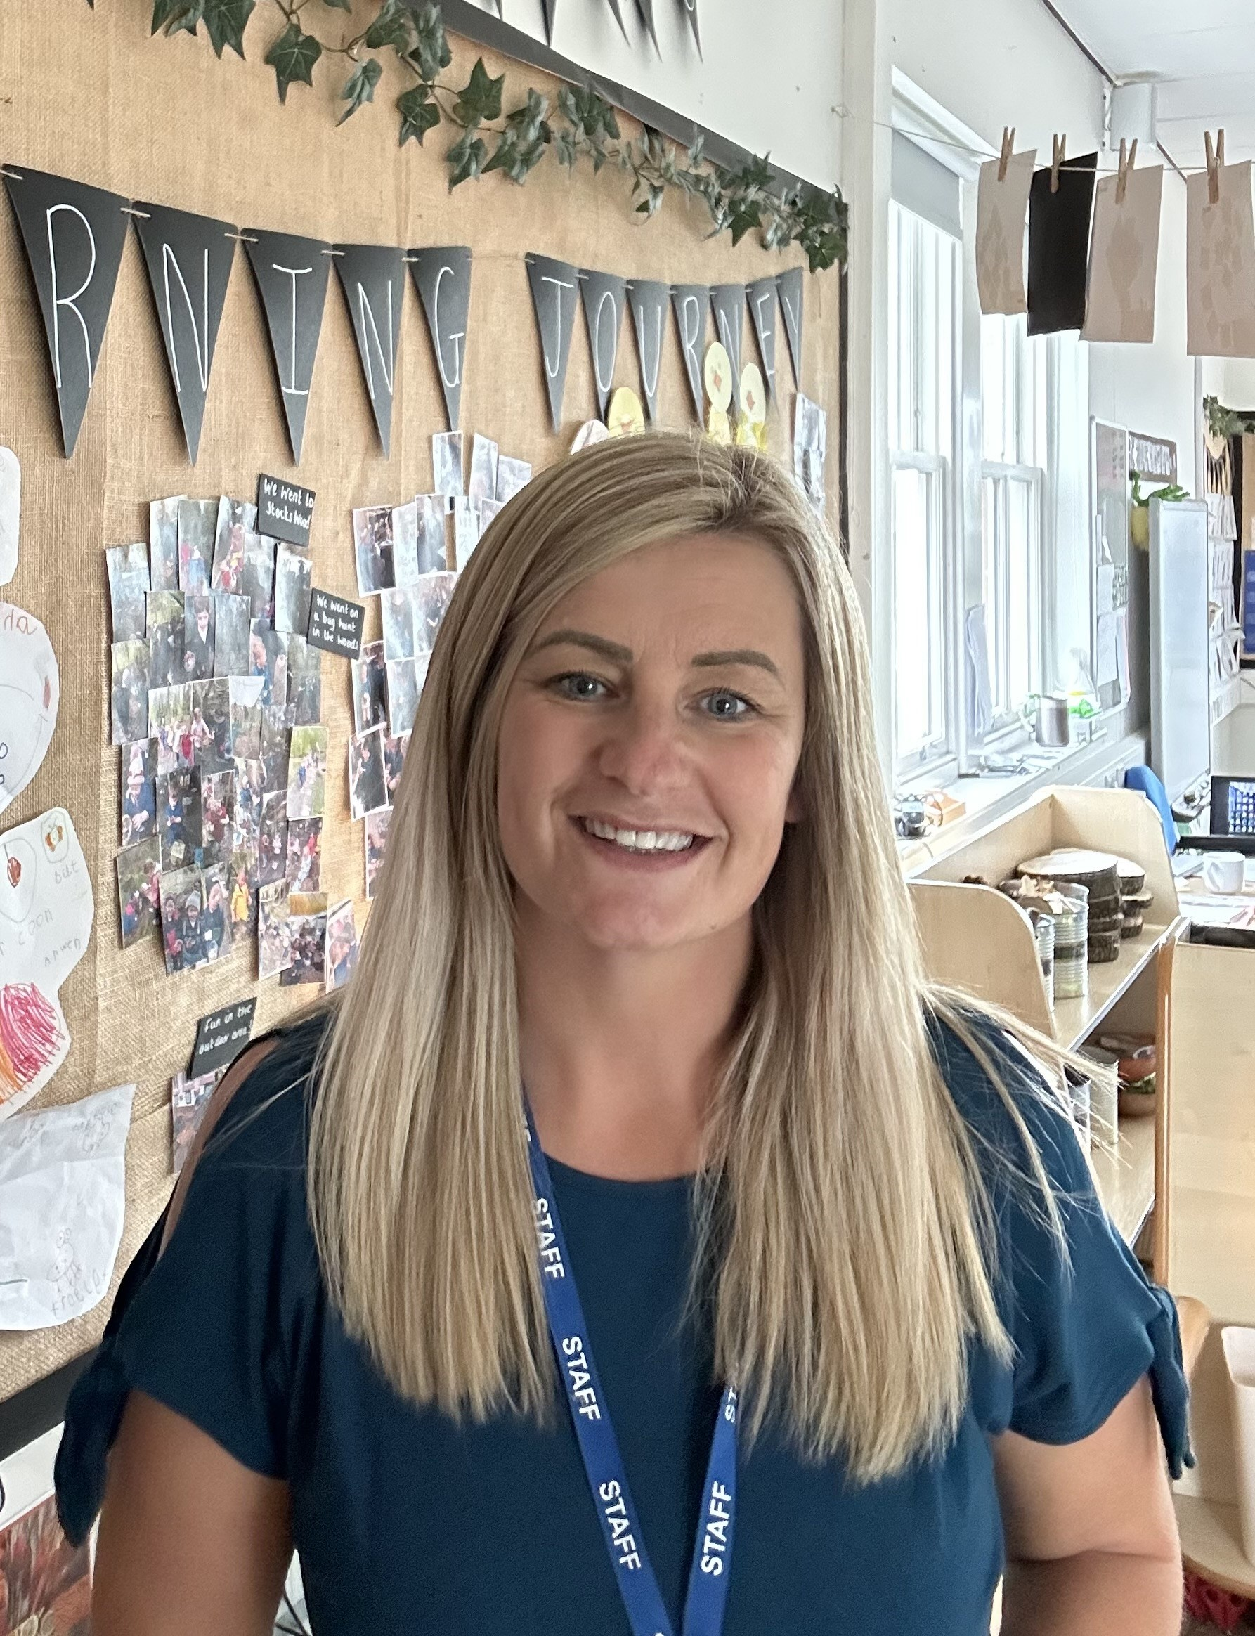
 |  | 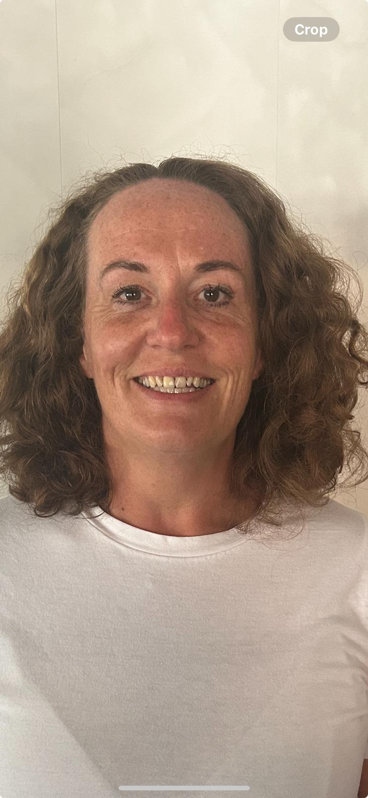
Miss Sammie Cook  Senior Teaching Assistant | Mrs Lisa Anderson  EYFS Lead & Reception Teacher | Miss Ellen Jenkinson  Senior Teaching Assistant

USEFUL INFORMATION – Uniform

Our school uniform consists of:

Royal Blue sweatshirt / cardigan with/without the school logo.
White or blue polo shirts.

Black shoes (Trainers for P.E. only)
Grey or black skirt, pinafore or trousers / shorts
In summer blue gingham school dresses can be worn

PE Kit:
Black/Dark Blue Shorts and plain white T Shirt
Navy blue track suit with/without the school logo
Trainers/plimsolls
In winter we advise children to wear jogging/track suit bottoms.

Cumwhinton book bags can by purchased in the uniform shop, these are recommended rather than an alternative school bag as they fit into the children’s trays. We also ask for a pair of wellingtons to stay in school to be able to access the field area all weathers.

If children’s ears are pierced they should not wear anything other than retainers. All jewellery should be removed for PE.

THE CUMWHINTON SCHOOL DAY
School Lunches
School meals are available at a daily cost of £2.99 (once your children starts Year 3). Our lunches are provided by Orian and we use their online ordering system called School Hub. Your user instructions and password will be forwarded to you separately. Children in Reception, Yr 1 and Yr 2 are currently entitled to universal free school meals, which we encourage all children to take. If your child would rather bring a packed lunch please contact the school office.
Sample menus from Orian can be found on our school website. Meals can be ordered two weeks in advance via School Hu. Provision is also made for children who bring a packed lunch, but no crockery or drink is supplied. We encourage healthy eating habits and ask that parents do not send fizzy drinks, or include sweets in packed lunches. Packed lunches should be sent in a named container.
We are a nut-free school so no one should bring any nuts or items containing nuts into school.

Milk
Children under 5 years of age are entitled to free school milk and will be automatically registered. Parents can order milk for pupils once they have had their 5th birthday via the Coolmilk website (www.coolmilk.co.uk)

Snacks and Water Cumwhinton School is part of The School Fruit and Vegetable Scheme, which helps your child to achieve 5 a day. In addition to this we have ‘rolling snack’ in Reception every day. Here your child has the opportunity to taste a variety of savoury snacks across the week. Rolling snack also encourages your child to develop self-regulation skills such as pouring, cutting, spreading etc. Ofsted were very impressed with rolling snack and commented on how it promoted independence from an early age. In order to facilitate this we ask parents for a voluntary contribution of £1 per week. (Payments can be made half termly or weekly). Mrs Anderson will provide more information about this during home-visits. This contribution also covers milk, baking and play-dough/craft materials, which we do regularly in reception. Water bottles are available and children can drink water freely in their classrooms throughout the day. Each child is given a water bottle, provided free on entry to the school and replacement bottles are available at a charge from the school office.

First Aid & Medication
All members of the staff in EYFS are trained in emergency first aid and/or paediatric first aid. Minor injuries are dealt with accordingly and head injuries, however slight, are recorded and reported to parents. In the case of a more serious injury, or sudden illness occurring during the school day, parents are informed immediately and asked to collect their child from school.
We require daytime emergency contact numbers, including mobile telephones where appropriate, for this purpose. Please ensure that contact numbers are up to date at all times. If parents, or their appointed guardians are unavailable in a medical emergency, your child will be transferred to the Cumberland Infirmary (A & E) and a member of staff will remain with your child until you can be contacted. If your child suffers a head bump during the school day a text message will be sent as well as sending home a bump note.
If your child suffers from asthma his/her name must be included on the asthma register and a duplicate inhaler, clearly marked, will be kept in school at all times for emergencies. School must be informed about any other medical condition requiring regular or emergency medication and special arrangements will be made for the administration of such medicines.
If your child has any medical conditions, or takes any medication please contact the school office as we will require you to complete with us an Individual Healthcare Plan for your child.
Breakfast Club & After School Club
Our wraparound facility clubs runs from 7:45am—8:50am and 3.20pm—6pm Monday to Friday for breakfast club and Monday-Thursday for After School Club. Breakfast and quiet activities are provided in the morning and at After School Club. A planned programme of activities are available everyday which we hope will encourage the children to have fun both indoors and outdoors. For further information please contact the school office on admin@cumwhinton.cumbria.sch.uk

Absence Details
Details of any planned absence e.g. hospital appointments, should be notified to school via the school email, prior to absence (including a photo of any appointment letter).
Details of absence or late attendance not previously notified must be made to school by telephone or email before 9.15 am giving the reason and expected day/time of return. Where a child fails to attend and there has been no notification of absence, a telephone call will be made by the school to the named contact person.
Families are not permitted to take holidays in term time. If, however you feel there are exceptional circumstances you must request this in writing to the Headteacher to consider. An absence request form is available from the office. We are now legally obliged to record any unauthorised absences from school on your child’s record.
School Timings
The school day starts when the whistle is blown at 8.45am and registers are taken at 8.50am.
School finishes for Reception at 3.15pm and the rest of school at 3.20pm. If your child is booked onto the bus they will be taken to the bus by a member of staff at the end of each day.

Children with Special Needs
The Governors and staff recognise that all children have a right to a bold, brilliant, relevant and differentiated curriculum. We aim to create a happy, educationally exciting and positive environment in which all pupils can develop to their full potential. We recognise that children are individuals and that each one has needs special to him or her, and that some gifted children may also have special needs.
If you would like to read a copy of our School Local Offer for the support of children with special educational needs, including that for children with a Statement of Special Education Needs/Educational Health Care Plan, please see our website.

If you would like further information please contact Mr Ian Murphy (Headteacher) for further information.
FIND OUT MORE...
We are looking forward to welcoming you into our Cumwhinton family, please do not hesitate to contact us if you have any questions or queries.

Telephone: 01228 560 400

Email: admin@cumwhinton.cumbria.sch.uk

Follow us on Instagram: cumwhintonschooleyfs to find out more about our Early Years

Facebook: Cumwhinton School

With kind wishes,

Mrs Lisa Anderson – EYFS Lead and Class Teacher

